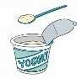

Starchy Foods
Base each meal on a starchy food, such as bread, potato, rice, pasta, couscous.
Starchy foods give energy, fibre, vitamins and minerals.

- Bread, try different types, such as pitta bread, wraps, bread sticks or bread rolls.
- Other starchy foods, such as pasta or rice.
- Whole grain varieties are best for fibre, which is
vital for a healthy digestive system.

Fruit & Vegetables

Don't forget to include fruit and vegetables. You can use fresh, frozen, tinned or dried. Fruit and vegetables are full of vitamins, minerals and fibre necessary for the body to function properly and to keep you strong and healthy.

- Add tomato, lettuce, cucumber or beetroot to a sandwich
- Include a portion of salad or roast vegetables
- Fresh fruit, such as apple, banana or pear.
- Dried fruit, such as raisins, apricots or figs.
- Fruit salad (fresh or tinned in juice) or vegetable salad.
- Finger foods, such as cherry tomatoes, cucumber sticks or celery are good with a dip, such as hummus or guacamole.
Using fresh fruit and vegetables, which are in season can help the environment

All packed lunches should contain at least one portion of fruit and one portion of vegetable or salad.

Milk & Dairy Foods
Up to the age of 5, milk is provided for children who want it and after that, parents can purchase it if they wish. Ask your school for information.

- A side dish of a low fat, low sugar yoghurt or low sugar rice pudding provides calcium necessary for strong bones and teeth as well as providing protein and vitamins
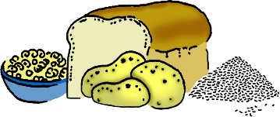


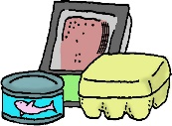
Meat & Alternatives

Add some protein, for example meat, fish, eggs, beans or pulses. Protein foods build muscles and provide minerals.
- Lean meats, such as chicken, turkey or ham.
- Include oily fish, such as pilchards, sardines or mackerel at least once every three weeks
- Cheese, such as cottage cheese, edam or soft cheese.
- Egg, such as quiche or omelette.
- Meat alternatives, such as tofu or tempeh.
- Dishes containing pulses, beans or meat, for
example dahl, stew or bean salad.
 Use butter, margarine, mayonnaise or salad dressings sparingly, because these can be high in fat, or use lower fat alternatives.
 The school does not allow nuts in packed lunches.



A Packed Lunch Guide for Parents

A healthy packed lunch is a balanced meal with a variety of nutrients to give your child the energy to learn, grow & develop.

Drinks
Drinks, especially water, help children to concentrate
and feel well. Water is freely available in school.

- You could try adding chopped fruit into water bottles to create new flavours
Avoid squash, fizzy drinks and flavoured water, even those labelled ‘sugar free’ or ‘no added sugar’ as these can contribute to tooth decay and have little nutritional value

Healthier Swaps
- Replace sweets and chocolate with dried fruit, a small bunch of grapes or fruit salad or sugar-free jelly.
- Replace cakes and pastries with fruit bread or malt loaf.
- Replace salted savoury snacks with rice cakes or breadsticks.

Snacks & Confectionery
Snack foods may be included occasionally but aim to make healthier choices. Snack foods tend to be high in fat, sugar and salt. Foods high in fat can cause excessive weight and may lead to heart disease. High sugar foods are high in calories and bad for teeth. High salt foods may increase blood pressure, which can lead to heart disease and some cancers.
Chocolate, sweets, chocolate spread, jam, salted savoury snacks and crisp like products should not be included in lunch boxes. Hot school lunch desserts are only allowed cocoa powder and no confectionery.

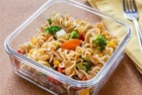
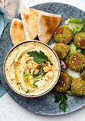
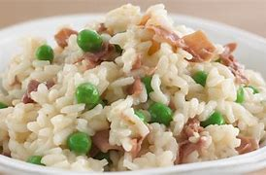
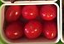
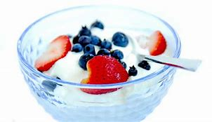
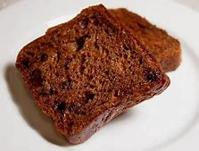
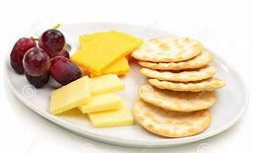
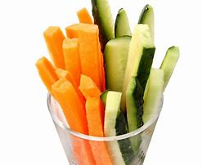
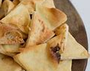
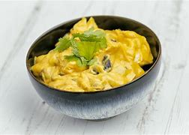
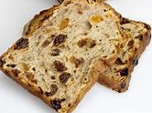
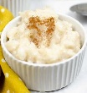
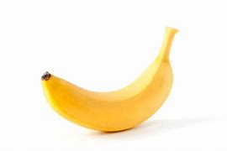
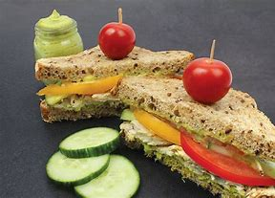
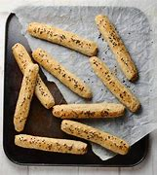

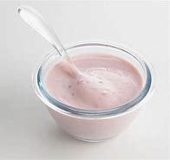
A week of possibilities!
Day 5
Hummus with
falafel/chicken bites &
slices of wholemeal wrap

Strips of mixed peppers

Tub of apples & raisins

Pot of sugar free jelly
Day 4
Brown rice or couscous
with peas & salmon/beans

Cherry tomatoes

Low fat/Low sugar yoghurt
With strawberries &
Blueberries

Slice of malt loaf
Day 3
Curried mayo egg/chicken
& chickpeas

Wedges of plain Naan

Carrot & Cucumber Sticks
Cheese, crackers & grapes
Day 2
Turkey/Cheese & Pepper
Sandwiches with cucumber
and cherry tomatoes

Small banana

Slice of fruit bread

Small pot of low sugar rice pudding
Day 1

Tuna/Quorn & cucumber pasta
salad

Low fat/Low sugar yoghurt

Small bunch of grapes

Wholemeal Bread sticks

Don’t forget your water every day!



