Welcome to

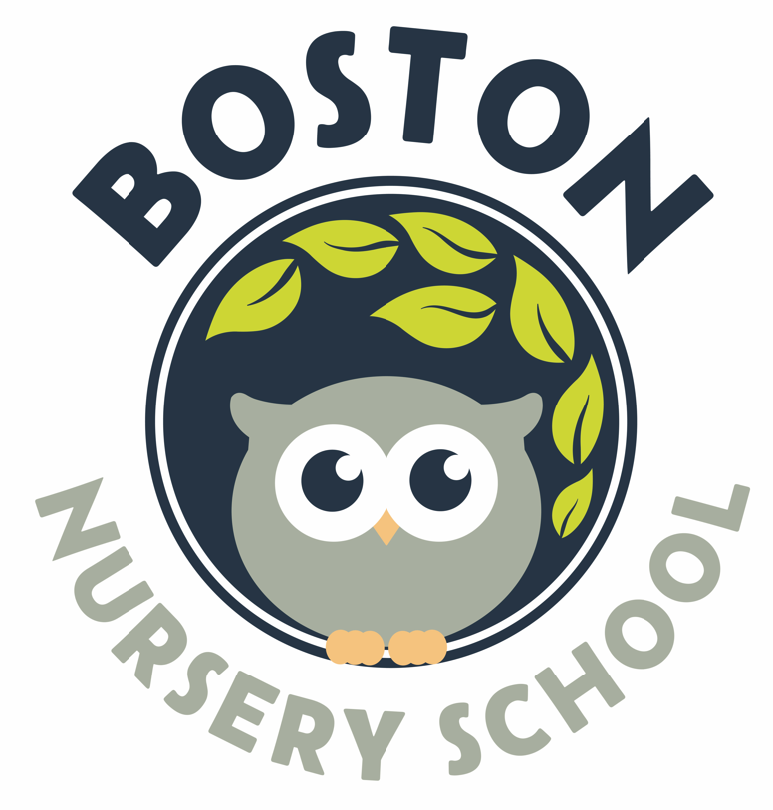

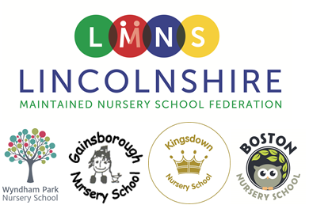

What is LMNSF?
Lincolnshire Maintained Nursery School Federation (LMNSF) is a family of Lincolnshire Nursery Schools that work together. They have an Executive headteacher – Laura Cook, who oversees all the schools.
Each school has a Head of School and they are the main point of contact for families.
By working together we gain many benefits – we can share staff, ideas and expertise. We are really proud of the work we do as a federation and how it has such a positive impact on the children, staff and families at our schools.

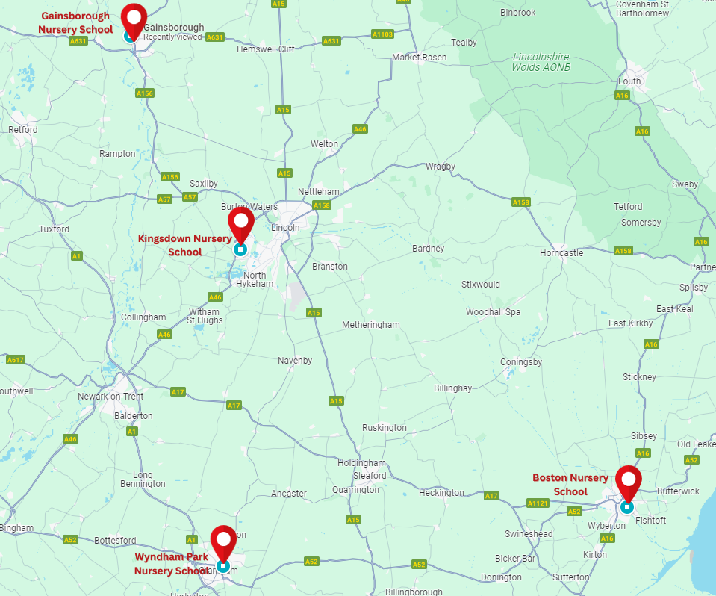

You can find out more about the work of the Federation on www.LMNSF.education

Laura Cook – Executive Head
Laura works across several Lincolnshire Nursery schools as Executive Headteacher. She has been a teacher in Early Years for 22 years. She thinks she has got the best job in the world and loves chatting to the children about what they have been learning – she especially likes popping into the classroom on days when the children have been baking!
Laura has two children of her own – Charlie and Emily. She often wonders how it can be so much easier to look after over 100 children at school then it is to take care of two at home!

Nursery Team

The Nursery is led by the Head of Nursery Ella Masterton, who teaches alongside another qualified teacher, Lauren Crawford. The Head of Nursery is an experienced early years education specialist and Lauren is also dedicated to high quality early years education. The Nursery is additionally supported by Teaching Assistants and Childcare Assistants

Nursery Sessions
We are open for breakfast club from 7:45 am and can offer afterschool clubs until 5:15pm.
Our day consists of a 3-hour morning session (8:45am-11.45am) or a full day session (8:45am-2:45pm)
We accommodate three and four-year-old funded children or children that are wanting to pay for sessions until their 15 hours funded sessions start. We also offer the opportunity for children to stay for extra sessions on top of their funded sessions if places allow.

The Nursery also has sessions for two-year-old children who are eligible for the two-year-old funding, or for children who want a paid two-year-old space at a cost of £16.50 for a three-hour session We also offer the opportunity for children to stay for extra sessions if places allow.

The fees are payable to school in advance.
Any additional hours over your 15/30 hours entitlement will be charged at £5.50 per hour (£2.75 for extended Afterschool Club) see below .

Session Times and Prices:
Breakfast Club (1 hour) £5.50 | 7.45am – 8.45am
Morning Session (3 hours) £16.50 | 8.45am – 11.45am
Full Day Session (6 hours) £33.00 | 8.45am – 2.45pm
Early After School Club (1 hour) £5.50 | 2.45pm – 3.45pm
Late After School Club (1 hour) £5.50 | 3.45 – 4.45pm
Extended Afterschool Club (30 minutes) £2.75 | 4.45 – 5.15pm

To enable the Nursery day to flow smoothly, we would appreciate it if you would arrive for your child’s session on time.

Working parents, who meet the Government eligibility, will be able to access up to thirty hours of free, early education childcare for their two, three and four-year-olds.

For further information, and to register with the Government Childcare website relating to funding, please visit: www.childcarechoices.gov.uk or scan the QR code.

The Aims of the Nursery:

To establish good relationships between Home and School, which enable us to continue the valuable learning and development already started at home;

to support, encourage and observe the children, and so help them develop independence, self-confidence, consideration and respect for others;

to create a happy, secure and stimulating environment where children discover for themselves that learning is fun;

to provide a broad and balanced curriculum that encourages the all-round development of each child, and provides a solid foundation for future learning;

to prepare children for primary school and ensure we have equipped them with the knowledge and skills needed for school readiness through a curriculum that develops speech and communication, maths and reading.

Curriculum Intent
The curriculum at Boston Nursery School has been designed to equip our children with the knowledge and skills that will prepare them for primary school - ‘School Readiness’.
By providing key skills and knowledge in speech and communication, mathematics and reading, our children will be better placed to take advantage of the opportunities, responsibilities and experiences available to them when they begin primary school.
We are aware that a child’s primary education takes place at home. We aim to engage, involve and support our children’s parents and carers. Our key areas to develop are: Speech and Communication Skills, Reading Knowledge and Skills, Mathematical Knowledge and Skill and Parental Engagement

Reporting to Parents

Your child’s progress and development are assessed and monitored as on ongoing process. A learning summary and next steps record are shared with parents twice a year - in the autumn and spring terms – when we will suggest ideas for providing support at home. This is followed by a progress report which is sent home at the end of the year. We recognise the key impact of the home-school partnership on the individual progress and achievement of each child.

If parents are worried about their child, they can discuss any concerns with the staff at any time. However, if an appointment is necessary, please arrange one by telephoning or emailing the school office.

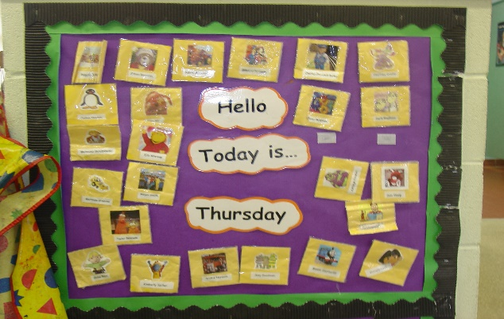
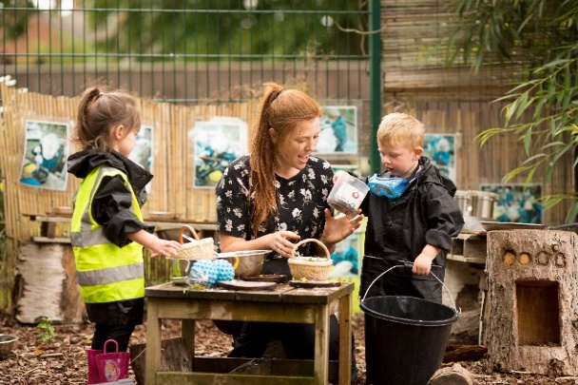

Caring for your child

In Nursery, we only administer prescribed medicines for chronic medical conditions such as asthma. All medicine(s), labelled with the child’s name, must be handed to the Nursery Teacher for safekeeping if a written plan has been agreed.

Children suffering from infections must be kept at home. If your child has sickness and/or diarrhoea they must be kept at home for 48 hours after the last incident. This is in line with the National Health Guidance for Schools. Please telephone, email or send us a note if your child is absent.
An emergency contact or telephone number is required. This will be used if your child becomes ill during the sessions.

Collecting and Delivering

For the safety of our children, please park in the allocated spaces, not on pathways, grass, or in an area that may obstruct others. The disabled parking bay is for use by disabled badge holders only.

The gate at the side of the main gates has a path that leads directly to the Nursery. Please ensure children keep to the path.

Great care is taken with the handover of the children between you and our staff at the beginning and end of each session.

We encourage our children to be more independent as they become familiar with the routines. Please collect your child from their classroom door at the end of the session. They will be ready for you with their coats on and their bags.
If there is any alteration in arrangements for collection at the end of each session, please let the staff know in advance by telephone or email. We will not release children to strangers, and require you to let us know if someone who does not usually collect your child is coming to collect them. The front door of the Nursery is kept locked during sessions.


Clothing
We encourage our children to wear our Boston Nursery School uniform of a blue school sweatshirt and/or T-shirt, with our Boston Nursery School Owl. Uniform may be purchased from www.myclothing.com. However, wearing of our uniform is not compulsory.

Children will be participating in activities that may be messy so we provide protective clothing. Please send children to the Nursery in clothing which is both appropriate and comfortable. Please provide a bag of spare clothes to have on your child’s peg too.
As we encourage independence, the children will be learning to put on their coats and fasten them up. They will need to remove and replace their shoes, and Velcro fastenings are ideal as children can manage these. We do not allow jewellery; however, stud earrings may be worn.

All children should bring a named pair of wellington boots to be left at nursery as we do a lot of outside learning.

Snacks
We provide all children with free milk, fruit and other healthy snacks. We also support our children to drink water and pour their own water to drink from a cup. You do not need to provide juice or water bottles.

Preparing your Child for Nursery

As you know, children seek independence in the course of their everyday activities at home. This should be encouraged as it will make their life at Nursery much easier.

We ask that you encourage your child to begin to develop the following on their own before starting Nursery School:

- go to the toilet independently, use toilet paper correctly, adjust clothing, wash and dry hands afterwards;
- use tissues and the ‘catch it, bin it, kill it’ approach to good respiratory hygiene;
- begin to manage their coats, zip, buttons and fastenings.

The Nursery School Day

The normal routine for each session proceeds in the following way: -

Welcome to school and registration
Free-flow, child-initiated learning
Group time
Adult-led activities and free-flow, child-initiated learning
Group time
Home time

Group time – Whole group learning time, covering themes such as days of the week, discussions about the weather, counting, stories, nursery rhymes, singing and activities linked to our theme.

Child-initiated learning

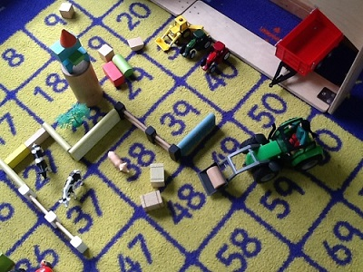
This is the time when children work through themed activities, learn to socialise with other children, share equipment and select activities that interest them.

Children will have the opportunity to choose indoor and outdoor activities.
The children choose from a range of activities that they are able to access independently.

Adult-led Activities

This is the time when children learn the skills of sharing, discovering, sorting, reasoning, matching and helping each other with support. The children are encouraged to tidy up each activity as they leave it to enable others to use resources after them. Activities are often linked to our theme and designed to enhance learning, fulfil next steps and cover the seven areas of development.

Early Years Foundation Stage

Children entering Nursery begin a curriculum called the Early Years Foundation Stage (EYFS). This is followed throughout their year in Nursery and continues until the end of their reception year.

The Early Years Foundation Stage curriculum is organised into seven areas of learning and development.

- Personal, social and emotional development.

- Communication and language.
- Physical development.

- Literacy.

- Mathematics.

- Understanding of the world.

- Expressive arts and design.

Early Years Foundation Stage

Structured activities and experiences are planned within these areas to provide the early years’ curriculum.

Children do not make a distinction between ‘play’ and ‘work’. Well-planned activities, both indoors and outdoors, are a key way in which young children learn with enjoyment and challenge.

Children behave in different ways when playing. Sometimes they will choose to be physical, sometimes they will describe and discuss what they are doing, and sometimes they will be quiet and reflective.

Our role is crucial. We:

- offer a challenging environment;
- support learning through planned play activities;
- extend spontaneous play;
- extend and develop language and communication through play.

Through play, in a secure environment, children can:

- explore, develop and represent learning experiences to help make sense of the world;
- practise and build up ideas, concepts and skills;
- learn how to control impulses and understand the need for rules;
- be alone, alongside or co-operating with others;
- take risks and make mistakes.

Classroom Experience

DISCOVERY
This area includes activities such as water, dry and wet sand-play, woodwork, dough, clay and other materials, including wet cornflour, pulses and pasta. There is also time for simple scientific experiments, including work with magnets, mirrors, colours and magnification.

CRAFT
Children are able to experiment with paint, fabrics, glue, string, foil, junk materials, buttons, pulses and pasta to create their own pictures, patterns and designs.

‘LET’S PRETEND’
During child-initiated activities, children have the opportunity to explore and use their imagination. Props are provided which are often related to our topics. Children are encouraged to use the equipment in a variety of ways, practise their language skills and socialise with others.
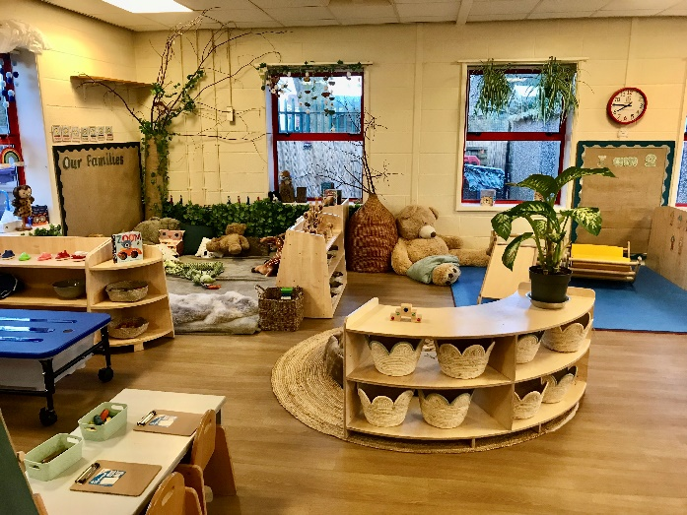
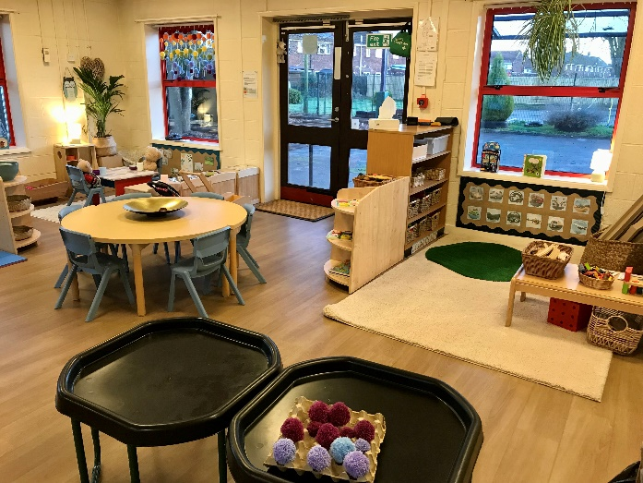

Please visit our website for further information: www.boston-nur.lincs.sch.uk

You can also find us on Facebook.

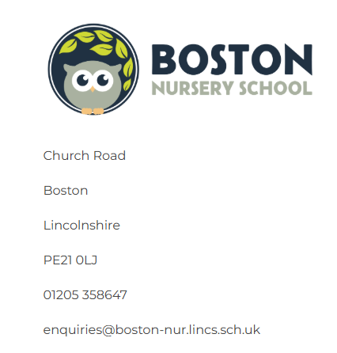
Please feel free to contact our administrator, Laura Carr on 01205 358647, or enquiries@boston-nur.lincs.sch.uk for further information, or to view the nursery school.

